**Architecture Design Document**

**HOME UTILITY TRACKER APP**

**By: Isha Limbasiya**

**Date: 14/06/2025**

1. **Data Flow Diagram**
   1. **Level-0 Diagram**

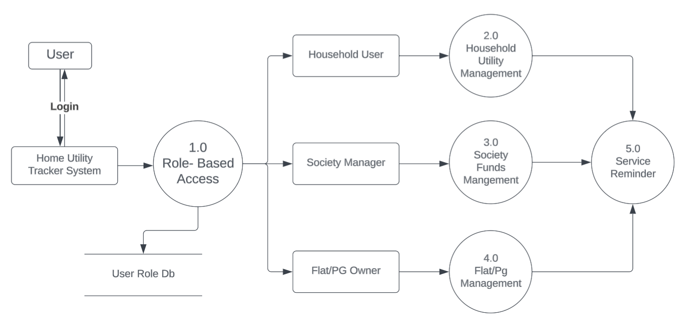

* 1. **Level-1 Diagram**

**Household Utility Management**

